ENFLOW OPERATIONS SYSTEM – PROJECT SUMMARY (FOR CHATGPT)
Background
I work for Enflow Sanitary, a manufacturer of PTMT connection pipes.
We are building an Excel/Google Sheets based Operating System (not ERP) that will be used daily by the factory.
The goal is to build a lightweight ERP inside Google Sheets that can comfortably run the business until approximately ₹15–20 crore turnover.
Everything should be extremely simple because the factory staff are not advanced Excel users
ENFLOW BUSINESS OS
1. Company Profile
2. Business Rules
3. Products
4. Customers
5. Vendors
6. Manufacturing
7. Inventory
8. Quality Control
9. Dispatch
10. Finance
11. HR
12. Reports
13. Dashboard KPIs
14. SOPs
15. Excel System
16. Automation Rules
17. Future Roadmap
SECTION 1 — Company Profile
This explains what Enflow is.
Example:
- Company Name – Enflow sanitary
- Business Type – Manufacturing
- Factory Location -Anekal 562106
- Year Started – 3 years
- Products Manufactured – PTMT connection pipe
- Brands – Enflow (Does contact manufacturing for other OEM and brands)
- Customer Types - B2B (business-to-business) clients.
- Business Model –
raw material supplier
contact manufacturing
Selling goods with own brand (Enflow)
- Company Vision
- Company Goals

SECTION 2 — Organization
This explains who does what.
Owner

↓

Manager (Taha)

↓

Operations Coordinator (Shivakumar)

↓

Store

↓

Production

↓

QC

↓

Dispatch
For every person we should document:
- Responsibilities
- Owner
- Dashboard only
- Decision making
- Major approvals

- Taha
- Customer orders
- Production priority
- Dispatch approval
- QC approval
- Customer communication
- Order planning

- Shivakumar
- Attendance
- Daily production
- QC entries
- Inventory transactions
- Dispatch preparation
- Daily reporting

SECTION 3 — Products
Instead of just listing products, define them properly.
For each product:
- Product Name – PTMT connection Pipe
- Product Code
- SKU
- Barcode
- Category – 1. Non braded -13mm
2.Braded – 13.5mm
- Length
18 in
24 in
30 in
36 in
48 in
1 mtr
1.5 mtr
2 mtr
3 mtr

- Variant
13 mm Round Nut
13 mm Hex Nut
13.5 mm Round Nut
13.5 mm Hex Nut

- MRP
- Weight
- Packaging
- BOM
- Production Time
Assembly Only
- Target
- 700 pipes/day
- Daily rate
- ₹350 per labor
- Assembly and packing
- Target
- 350 pipes/day
- Daily rate
- ₹350 per labor

SECTION 4 — Customers
Document everything about customers.
For example:
- Customer Master
Total 60+ customer
- Customer Categories -
B2B (business-to-business) clients.
- Dealer –
- Distributor - (Takes Enflow brand connection pipe
customers like SK traders, New Poonam hardware, mataji marketing etc….)
- OEM – (Currently we are providing services for more 15 OEM like aura industries, Idol, CS water taps etc…
- Job Work -
- Credit Days- (Average credit period is 21 days)
- Payment Terms (Bank transfer, payment before bill)
- Dispatch Method (By transport like VRL, Jaypur golden etc..)
- GST
- Freight Rules- (transportation cost under customer’s end )

SECTION 5 — Sales Process
Enquiry

↓

Quotation
Using Zoho books

↓

PO Received

↓

Order Entry (WhatsApp Group)
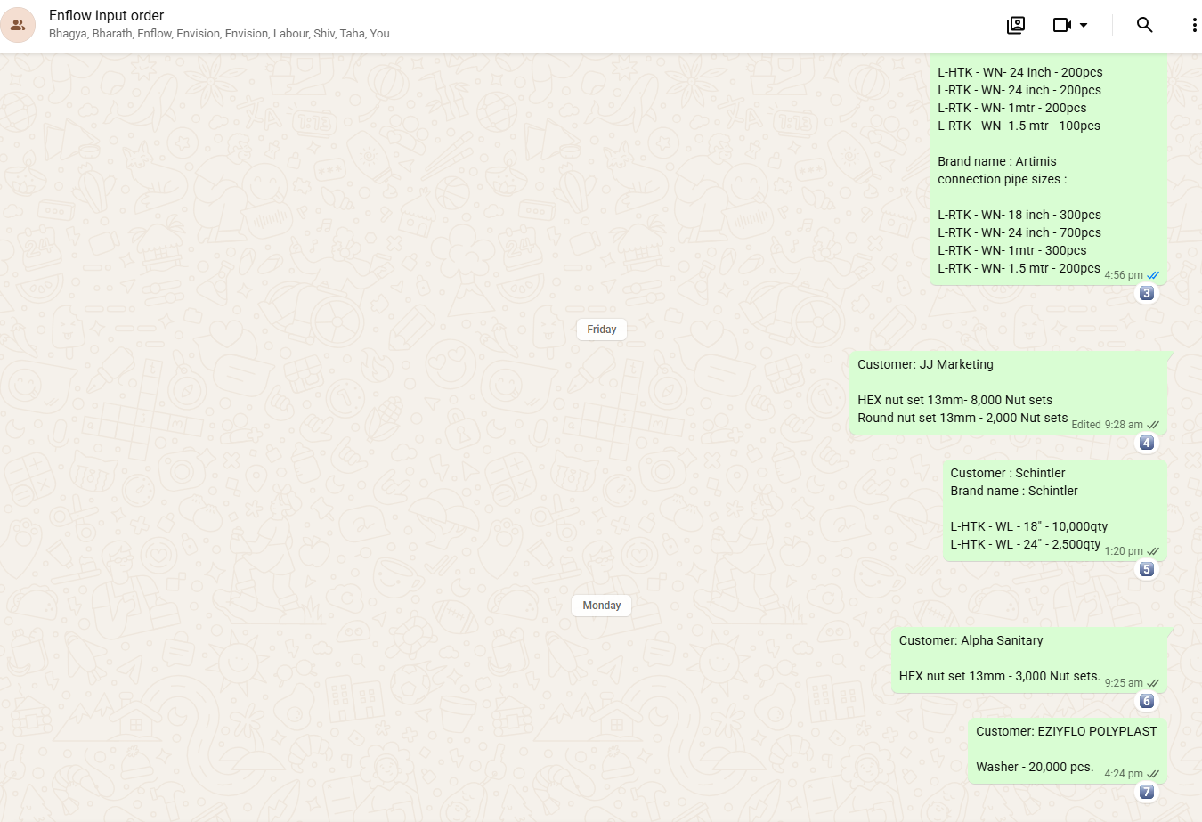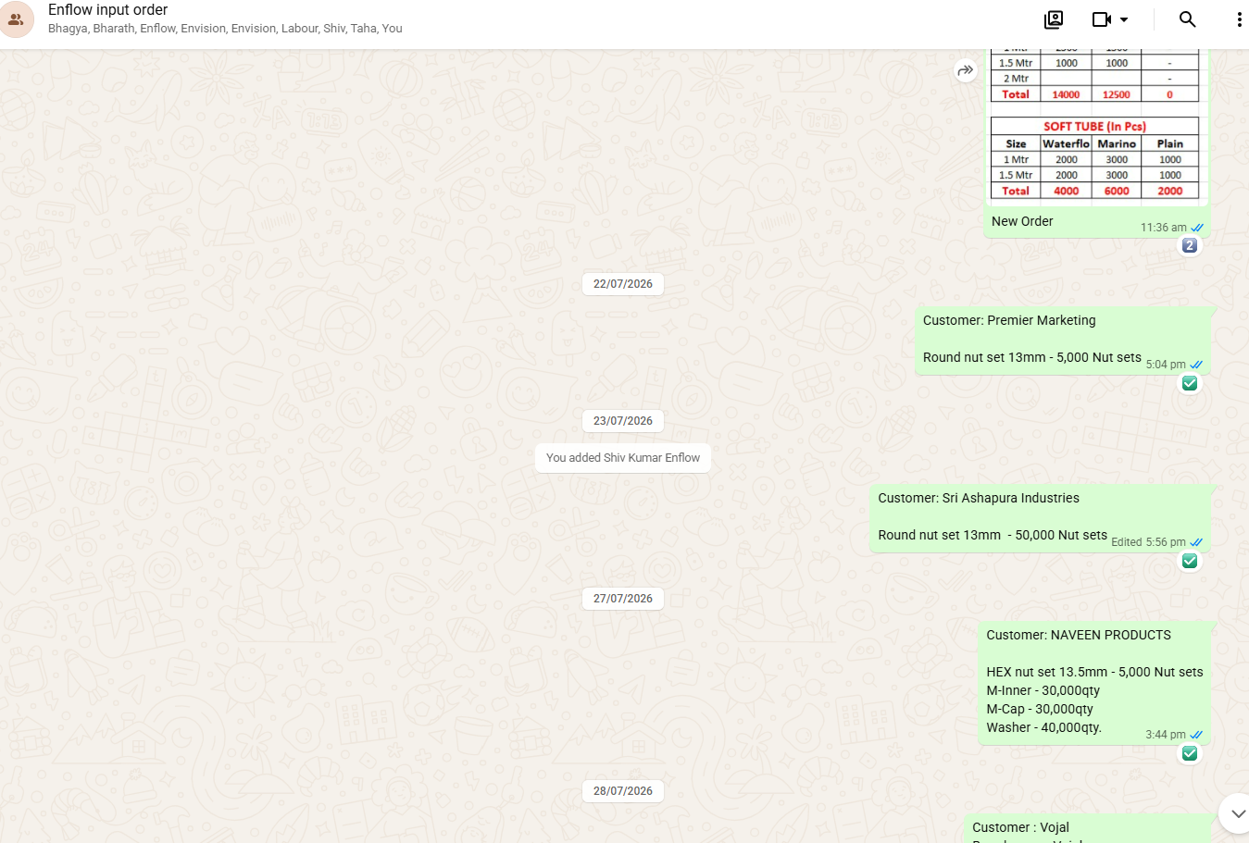

↓

Production Planning
- Availability of raw material
- Nut set
- Pipe
- Washer
- Cover
- Label

- Time taking to complete the order
- Availability of enough man power to complete the order

↓

Manufacturing

↓

QC
We have excel sheet for material in word and out word
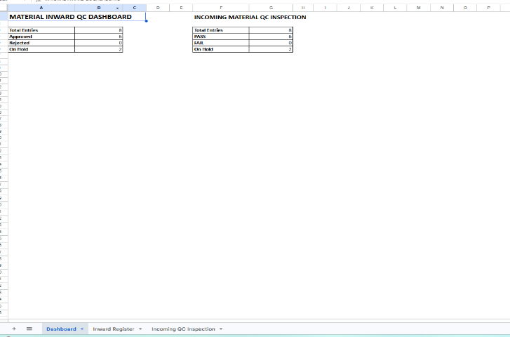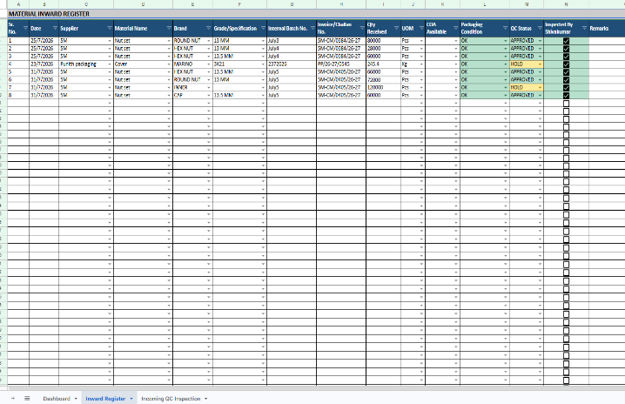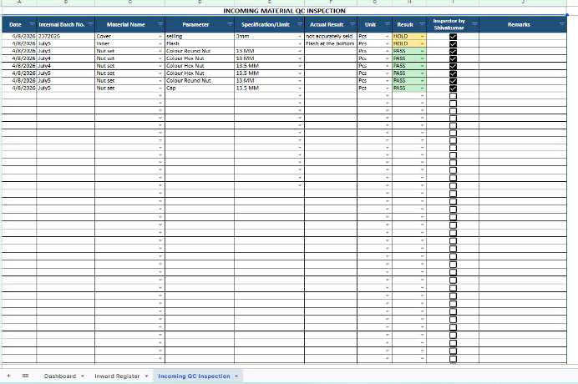
↓

Packing
We are maintaining a packing list manually with a sander template
↓

Dispatch

↓

Invoice
Using Zoho books
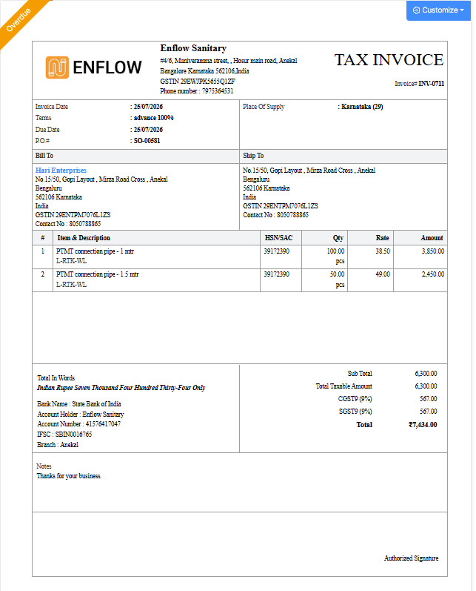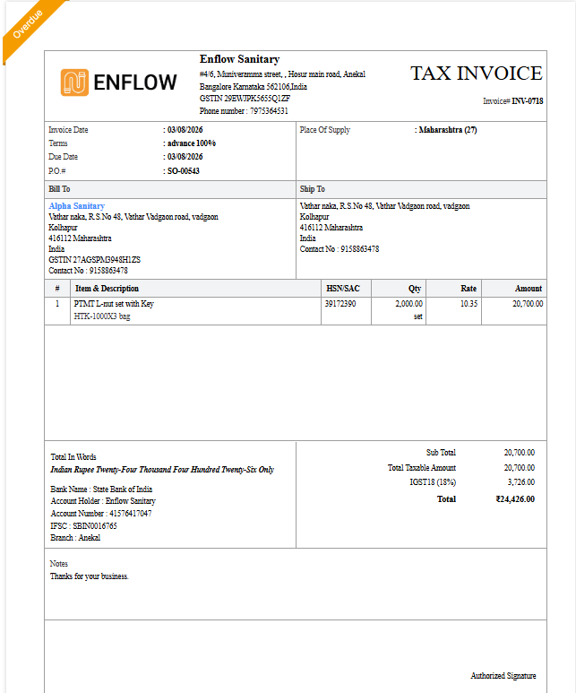
↓

Payment

↓

After Sales

SECTION 6 — Manufacturing
Here we go into detail.
Current Process
We will check the Availability of the raw material
↓
Cap Fitting
↓
Nut Assembly
↓
Machine Assembly
↓
Washer
↓
Sticker
↓
Cover
↓
Sealing
↓
Bundling
↓
Polybag
↓
Finished Goods
For each step we should define:
- Person Responsible
- Machine
- Material Used
- Inspection Point
- Possible Defects

SECTION 7 — Inventory
One of the biggest chapters.
Explain
Raw Material
- 13mm
- Round nut
- HEX nut
- Cap
- Inner
- Key
- Washer
- 13.5mm
- Round nut
- HEX nut
- Cap
- Inner
- Key
- Washer
- Cover
- 3X21
- 3X26
- 8X10
- Label
- 18 inch
- 24 inch
- 30 inch
- 1 mtr
- 1.5 mtr
- 2 mtr
- 3 mtr

- Pipe
- Brader(13.5mm)
- Non Brader (13mm)
- 18 inch
- 24 inch
- 30 inch
- 1 mtr
- 1.5 mtr
- 2 mtr
- 3 mtr
Note: Nut set, washer will be same for all the size and Brand for connection pipe. Cover, label, Pipe printing will be customized according to brand requirement.

↓
Finished Goods
Finisher goods will of 3 types
- Enflow connection pipe
(For 1pcs connection pipe it required)
- One nut set- (2pcs of nut+2pcs of cap+2pcs of inner+1pcs of Key+2pcs of washer)
- 1 pcs Enflow cover (with respect to size of the pipe)
- 2pcs Enflow label (with respect to size of the pipe)
- 1pcs of Enflow pipe (with respect to size of the pipe)

- Connection Pipe for OEM’s
- One nut set- (2pcs of nut+2pcs of cap+2pcs of inner+1pcs of Key+2pcs of washer)
- 1 pcs Brand cover (with respect to size of the pipe)
- 2pcs Brand label (with respect to size of the pipe)
- 1pcs of Brand pipe (with respect to size of the pipe)

- Nut set
- 1,000 set
- In one set of Hex type nut set (2pcs of nut+2pcs of cap+2pcs of inner+1pcs of Key+2pcs of washer)
- In one set of round type nut set (2pcs of nut+2pcs of cap+2pcs of inner+2pcs of washer)

- 2,000set
- In one set of Hex type nut set (4pcs of nut+4pcs of cap+4pcs of inner+2pcs of Key+4pcs of washer)
- In one set of round type nut set (4pcs of nut+4pcs of cap+4pcs of inner+4pcs of washer)

↓
Rejected
- Uneven color
- Flash
- Damaged pcs
↓
Scrap
↓
Rework
↓
Returned
Then define every inventory transaction.
Purchase-
Pipe -we place the order for Enflow 2 against the order
Nut set – we place order once in month.
Other raw material is purchased based on MOQ
Issue- Every morning Shivekumar issues the required raw material
Scrap- 1-2 % scrap comes while assembling
Production Consumption – monthly we are able to sell 1 lack connection pipe and 1.5 lack set of nut set
Finished Goods Receipt – we make packing list for finished goods, which we are recording the size, brand, total qty for each size.
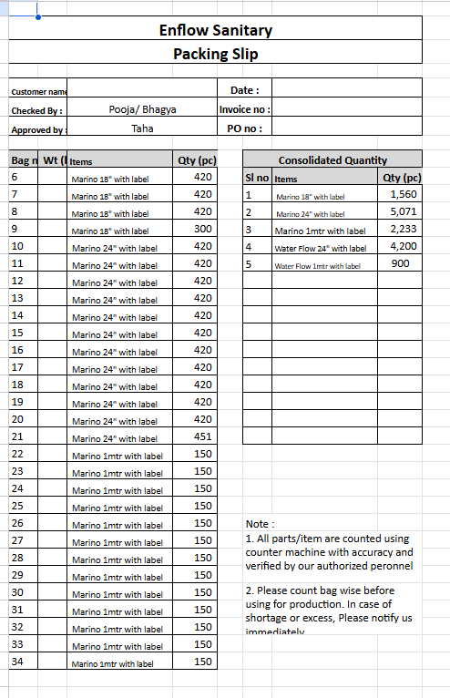

SECTION 8 — Quality Control
Current document only lists defects.
Instead document:
Incoming Inspection
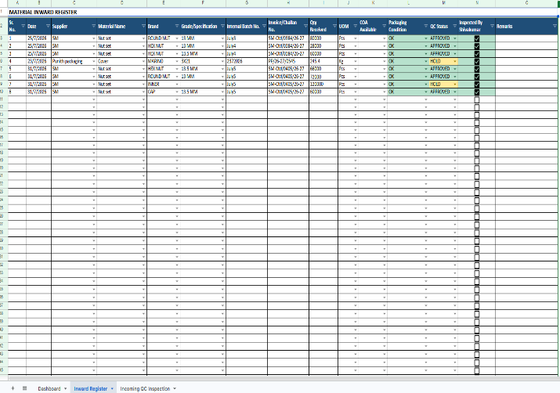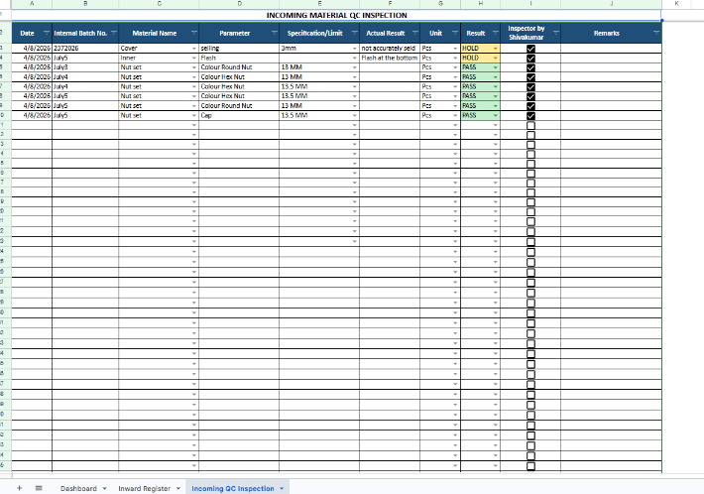
↓
In Process Inspection
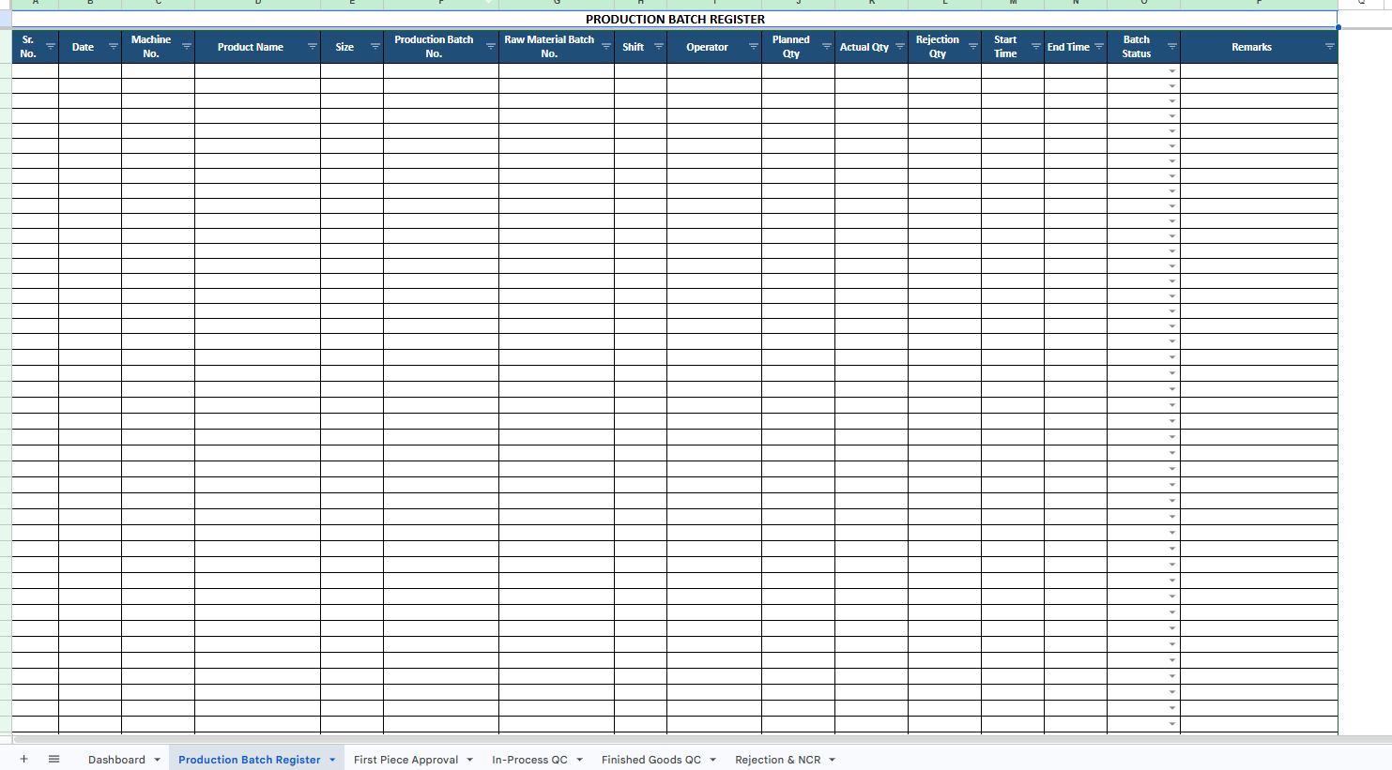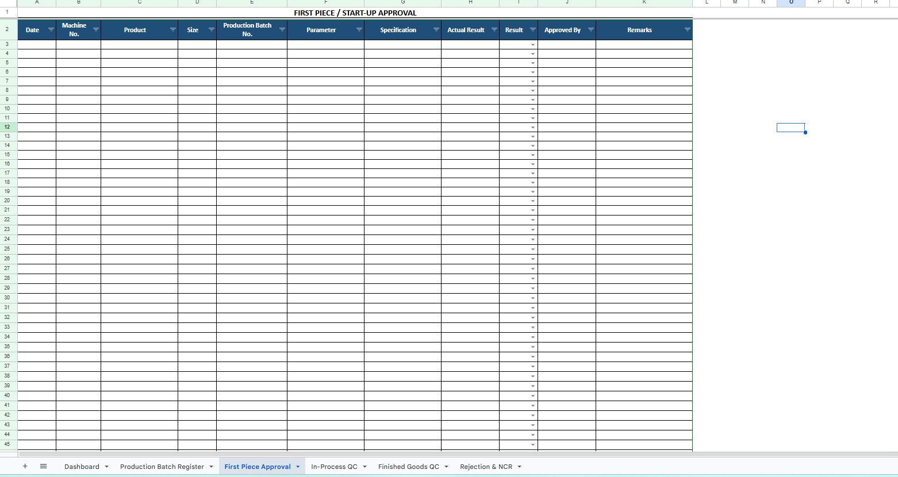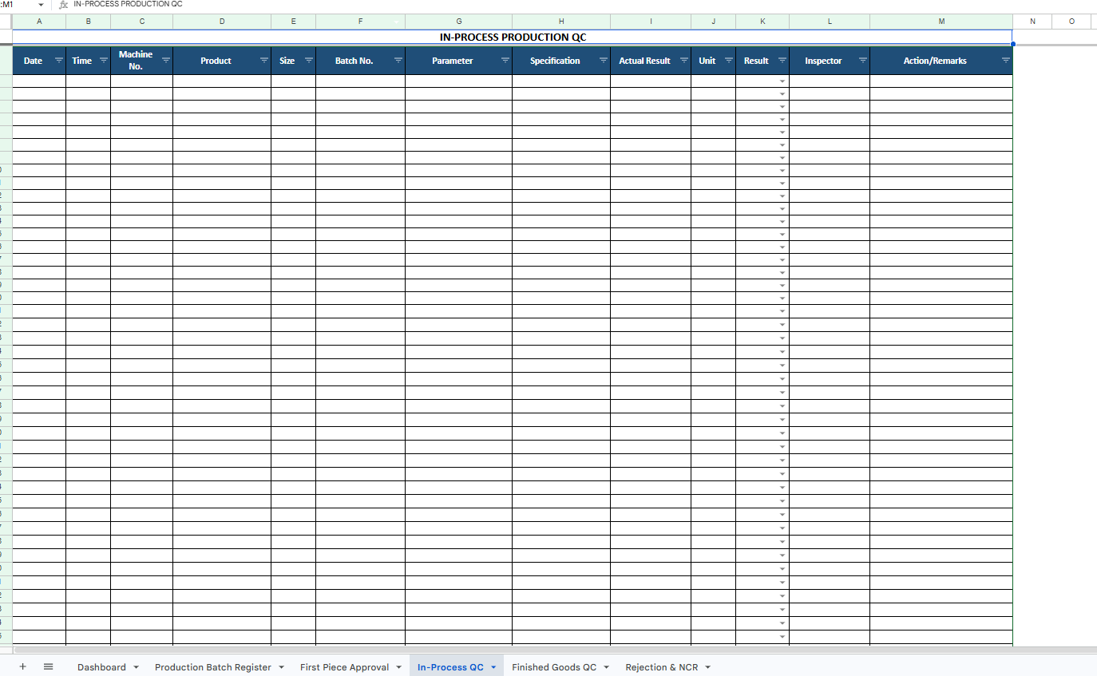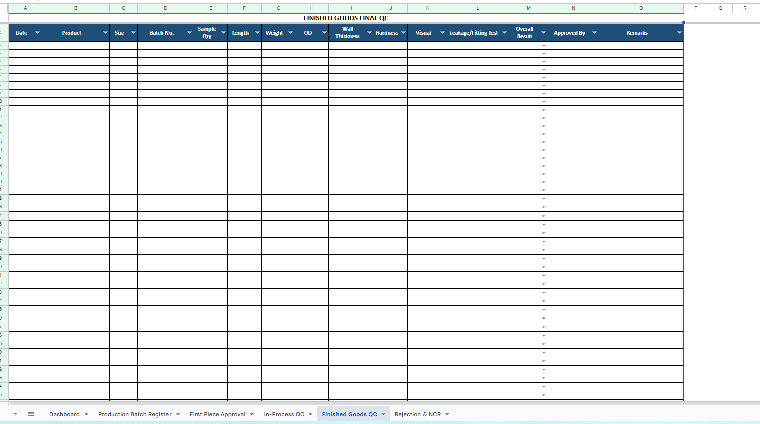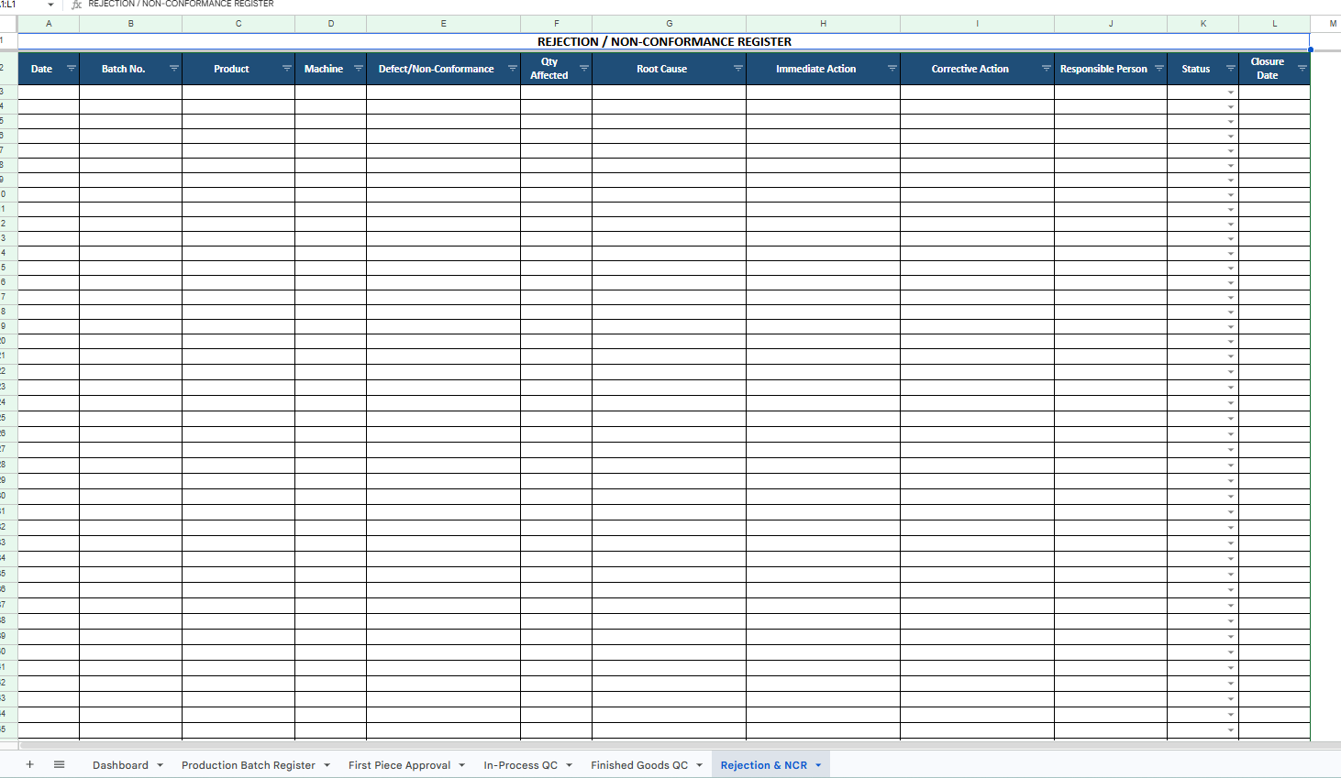
↓
Final Inspection
↓
Dispatch Inspection
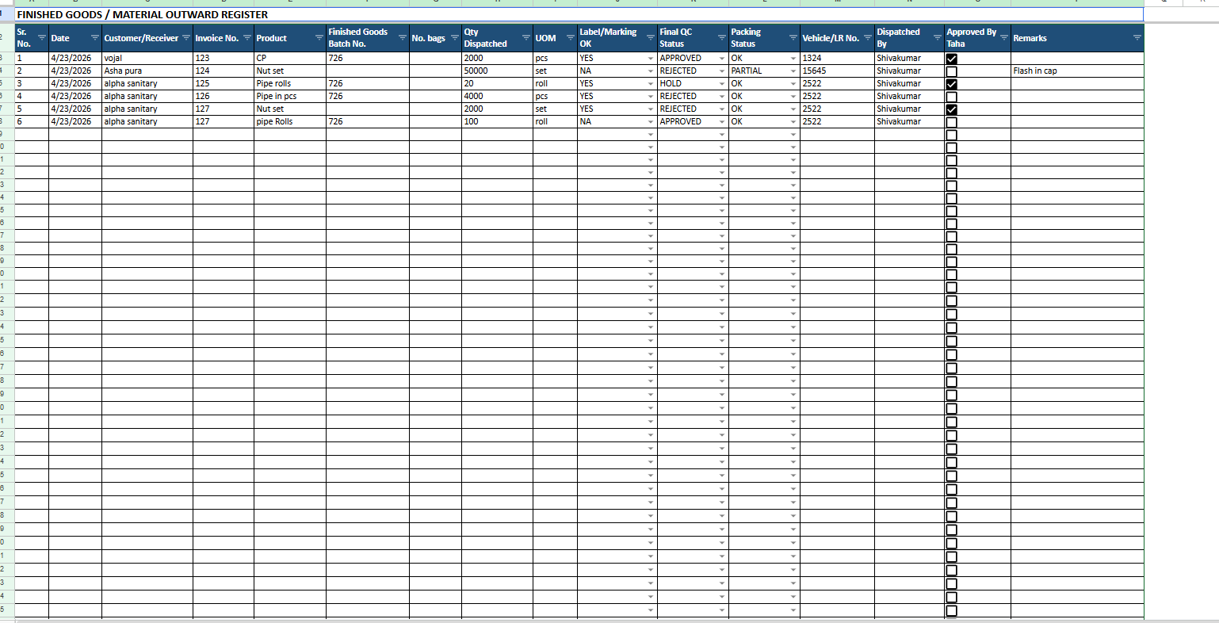
For every defect explain:
- Description
- Cause
- Prevention
- Corrective Action
- Responsible Person

SECTION 9 — Purchasing
Document
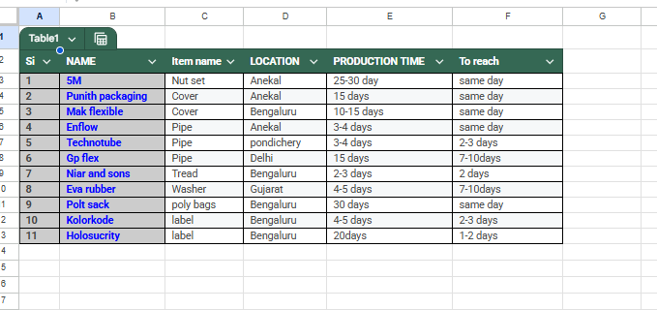
Vendor Selection
↓
Purchase Request
↓
Approval
↓
Purchase Order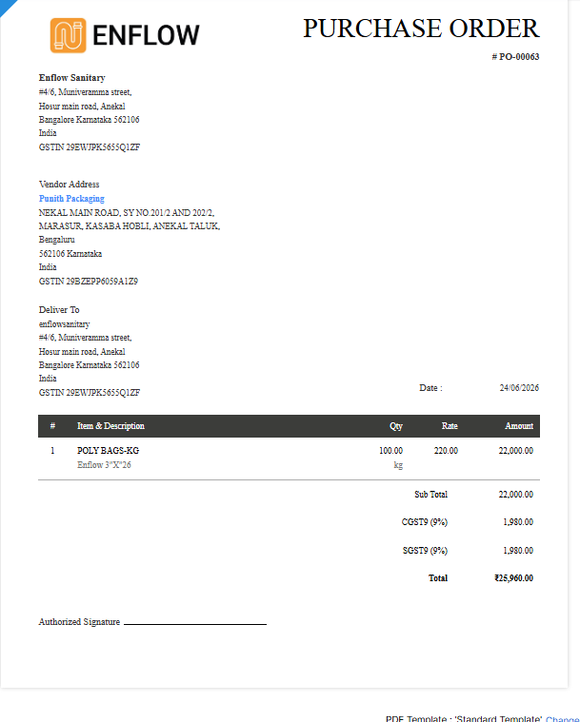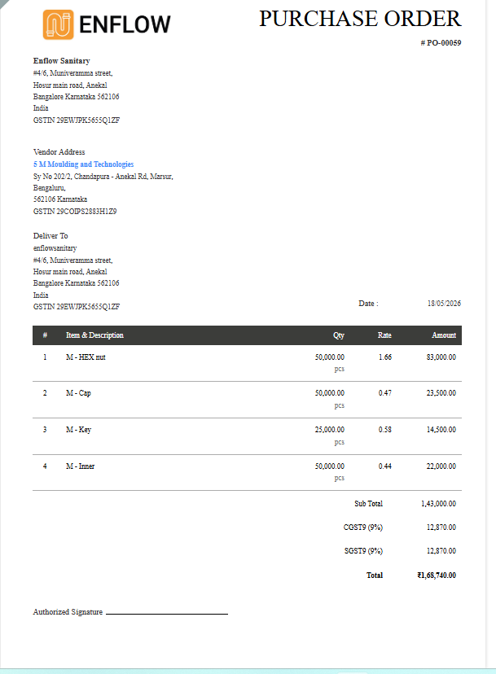
↓
Material Receipt
↓
QC
↓
Stock
↓
Vendor Payment
For few vender we pay cash payment, and for few with 10-15 days payment.

SECTION 10 — HR
Attendance – Daily manual entries from Shive Kumar in excel sheet
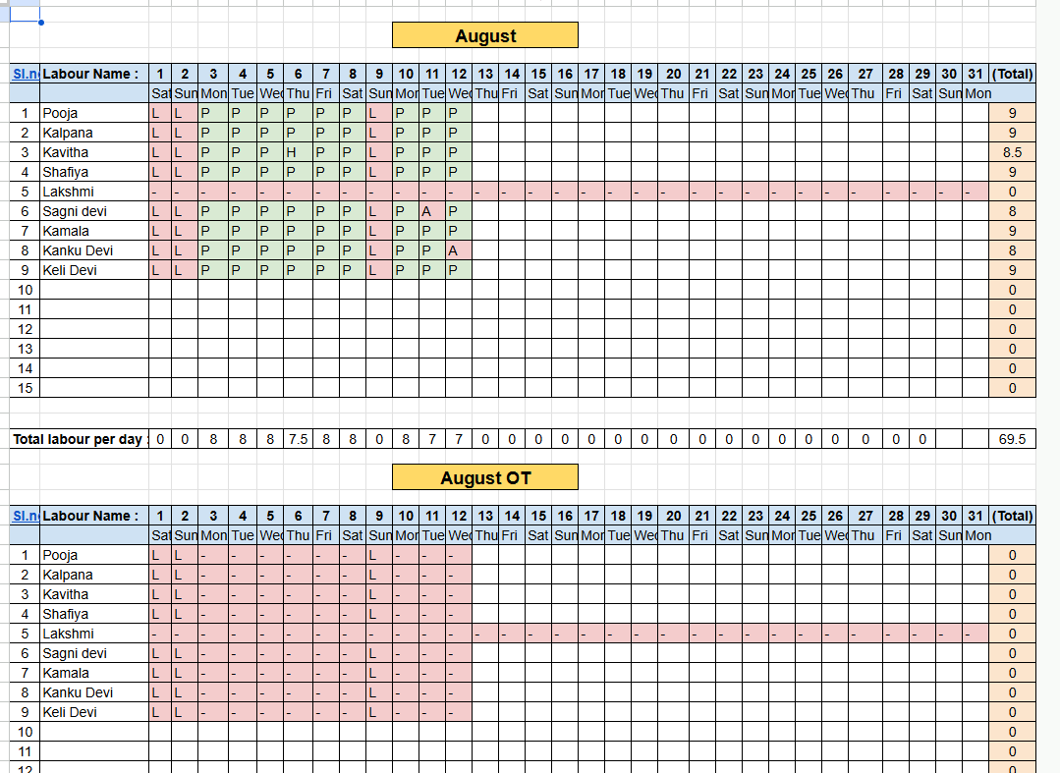
Salary – is paid end of the month through bank transaction.
in production team each person is paid Rs 350/- per day.
salary of production team is calculated based on total no of days present.
Overtime - if a person does over time, then they get paid 100/- extra.
Performance – is tracked by every day physical production report
Targets- 350 pcs with cover per day
or 700 pcs without cover per day
for over time 100 pcs.

Report | Purpose | Frequency | Owner | Input | Output | Example
Daily Production Report | Monitor daily production performance and target achievement. | Daily | Production Supervisor | Production plan, machine output, manpower details | Production quantity, rejection %, efficiency | 20,000 pcs planned, 18,500 pcs produced, 2% rejection
Weekly Dispatch Report | Track customer deliveries and pending dispatches. | Weekly | Dispatch/Logistics Executive | Sales orders, packing list, transporter details | Dispatched qty, pending orders, delivery status | 15 orders dispatched, 3 orders pending
Monthly Sales Report | Review sales performance and customer trends. | Monthly | Sales Manager | Sales invoices, customer orders, collections | Revenue, customer-wise sales, growth % | ₹25 Lakhs sales, 12% growth over previous month
Inventory Report | Monitor stock availability and prevent shortages. | Weekly/Monthly | Store Manager | Raw material stock, FG stock, purchase receipts | Current stock, reorder requirements, slow-moving items | PTMT Granules: 1.2 Tons available, reorder required
Labour Report | Track manpower utilization, attendance, and productivity. | Weekly/Monthly | HR/Admin | Attendance records, overtime sheets | Labour strength, absenteeism, overtime hours | 22 workers present, 95% attendance
QC Report | Monitor product quality and rejection trends. | Daily/Weekly | Quality Engineer | Inspection reports, testing results | Accepted qty, rejected qty, defect analysis | Rejection rate 1.8%, color variation issue identified
Machine Report | Monitor machine performance, downtime, and maintenance needs. | Daily/Weekly | Maintenance Engineer | Machine running hours, breakdown records | OEE, downtime, maintenance schedule | Extruder #2 stopped for 2 hrs due to heater failure

Training – 9:00 am to 6 :00pm
SECTION 12 — KPIs

ENFLOW — KPI Framework

1. Company-Level KPIs
These should be reviewed by management monthly.
KPI | Measurement | Target | Frequency
Sales Achievement | Actual Sales ÷ Target Sales | ≥ 100% | Monthly
Gross Profit Margin | Gross Profit ÷ Sales | ≥ 20%* | Monthly
On-Time Delivery | Orders delivered on time ÷ Total orders | ≥ 95% | Monthly
Production Achievement | Actual ÷ Planned production | ≥ 95% | Weekly
Overall Rejection | Rejected pcs ÷ Total production | ≤ 2% | Weekly
Customer Complaints | Valid complaints/month | ≤ 2 | Monthly
Receivable Days | Outstanding ÷ Average daily sales | ≤ agreed credit | Monthly
Inventory Accuracy | Physical vs system stock | ≥ 98% | Monthly
*We can change this based on your actual costing/margin structure.

2. Production KPI
This should be one of the most important KPI sections for Enflow.
KPI | Formula | Target
Production Achievement | Actual Production ÷ Planned Production × 100 | ≥ 95%
Production Efficiency | Actual Output ÷ Standard Output × 100 | ≥ 90%
Rejection Rate | Rejection ÷ Production × 100 | ≤ 2%
Rework Rate | Rework Qty ÷ Production × 100 | ≤ 2%
Machine Utilization | Running Hours ÷ Available Hours × 100 | ≥ 85%
Unplanned Downtime | Downtime ÷ Available Hours × 100 | ≤ 5%
Labour Productivity | Production ÷ Labour Hours | Improve monthly
Changeover Time | Average changeover time | Reduce monthly

Example
If the plan is:
25,000 pipes
and actual production is:
24,000 pipes
Production Achievement:
24,000 ÷ 25,000 × 100 = 96%
So the team scores 96%.

3. Quality / QC KPI
For Enflow, QC should focus heavily on pipe dimensions, colour, leakage, fitting, nut quality and customer complaints.
KPI | Target
First Pass Yield | ≥ 98%
Production Rejection | ≤ 2%
Rework | ≤ 2%
Leakage Failure | ≤ 0.5%
Dimensional Rejection | ≤ 1%
Colour Variation | ≤ agreed tolerance
Customer Complaint | ≤ 2/month
Complaint Closure | ≤ 3 working days

Important KPI
Customer Complaint Repeat Rate
If the same problem keeps appearing, simply closing complaints isn't enough.
Target:
0 repeat complaints for the same root cause.

4. Purchase / Vendor KPI
This is particularly important because your raw material, masterbatch, moulds/dies and components directly affect production.
KPI | Target
Material On-Time Delivery | ≥ 95%
Supplier Quality Acceptance | ≥ 98%
Purchase Price Variance | Within approved costing
Material Shortage | 0 production stoppages
Supplier Lead Time | Within agreed timeline
Vendor Response Time | ≤ 1 working day
New Vendor Development | 1–2/month where required

Vendor Score
I would give every major vendor a monthly score:
Quality – 30%
Delivery – 30%
Price – 20%
Response – 10%
Flexibility – 10%
Total = 100
This will help you identify which vendors are actually reliable.

5. Stores / Inventory KPI
KPI | Target
Stock Accuracy | ≥ 98%
Stock-out Incidents | 0
Excess Stock | Reduce monthly
Slow Moving Stock | Identify monthly
Material Issue Accuracy | ≥ 99%
FIFO Compliance | ≥ 95%
RM Availability | ≥ 98%
For Enflow, I'd also track:

Days of Stock Available
For example:
Masterbatch — 18 days
Raw material — 12 days
Labels — 25 days
Nuts — 15 days
This makes production planning much easier.

6. Dispatch KPI
KPI | Target
On-Time Dispatch | ≥ 95%
Dispatch Accuracy | 100%
Packing Accuracy | ≥ 99%
Short Shipment | 0
Wrong Item Shipment | 0
Dispatch Documentation Accuracy | 100%
Transport Damage | ≤ 0.5%

7. Sales KPI
For Enflow, I wouldn't measure salespeople only on sales value.
Use:
KPI | Weight
Sales Achievement | 30%
New Customers | 15%
Repeat Orders | 15%
Collection | 20%
Gross Margin | 10%
Customer Follow-up | 10%
This prevents someone from achieving sales by giving excessive discounts or creating poor-quality receivables.

8. Accounts / Finance KPI
KPI | Target
Collection Achievement | ≥ 95%
Receivable Days | Within agreed terms
Overdue Amount | Reduce monthly
Payment Processing | Within agreed timeline
Purchase Invoice Accuracy | ≥ 99%
Monthly Closing | By 5th working day
Cash Flow Forecast Accuracy | ≥ 90%

9. Maintenance KPI
This becomes important as your production volume increases.
KPI | Target
Machine Availability | ≥ 95%
Preventive Maintenance Completion | ≥ 95%
Breakdown Hours | Reduce monthly
Repeat Breakdown | 0
MTBF | Increase
MTTR | Reduce
Spare Availability | ≥ 95%
MTBF = Mean Time Between Failures
MTTR = Mean Time To Repair

10. Management KPI
This is different from employee KPIs.
Management should track:
KPI | Target
Revenue Growth | ≥ planned growth
Profit Margin | ≥ planned margin
Customer Growth | ≥ planned
Capacity Utilization | ≥ 85%
Working Capital | Within budget
Inventory Turnover | Improve
Customer Retention | ≥ 90%
New Product Development | As planned
Cost Reduction | 2–5% annually

⭐ The KPI Dashboard I Recommend for Enflow
Don't make management look at 50 KPIs every day.
Have 10 "North Star" KPIs on the main dashboard:

ENFLOW — MONTHLY KPI SCORECARD
# | KPI | Target | Actual | Score | Status
1 | Sales | ₹XX L | ₹XX L |  | 🟢
2 | Gross Margin | XX% | XX% |  | 🟢
3 | Production Achievement | 95% | XX% |  | 🟢
4 | Rejection | ≤2% | XX% |  | 🟢
5 | On-Time Delivery | ≥95% | XX% |  | 🟢
6 | Customer Complaints | ≤2 | X |  | 🟢
7 | Collection | ≥95% | XX% |  | 🟢
8 | Inventory Accuracy | ≥98% | XX% |  | 🟢
9 | Machine Utilization | ≥85% | XX% |  | 🟢
10 | Operating Profit | XX% | XX% |  | 🟢
Then each department has its own detailed KPI sheet.

SECTION 13 — SOP Library
Priority | SOP | Why
🔴 1 | Customer Order Processing | Prevent missed requirements
🔴 2 | Production Planning | Control delivery
🔴 3 | Production Process | Consistent output
🔴 4 | QC & Rejection | Reduce customer complaints
🔴 5 | Purchase | Control material availability/cost
🔴 6 | Inventory | Prevent stock mismatch
🔴 7 | Dispatch | Prevent wrong/short shipments
🟠 8 | Vendor Management | Improve supplier reliability
🟠 9 | Payment Collection | Improve cash flow
🟠 10 | Machine Maintenance | Reduce downtime

SECTION 15 — Business OS Design
Now we explain the workbook itself.
Every sheet gets documented.
We will be needing
Dashboard
Daily updates and communication
Settings
Master Data
Order planning
Daily production sheet
Attendance
QC and wastage
Dispatch
Inventory
You can add some more
Example
Daily Production
Purpose
Columns
Input
Formula
Output
Dependencies
Permissions

SECTION 16 — Automation Rules
This is where AI becomes powerful.
Examples
When Order Created
↓
Reserve Inventory
↓
Generate Production Requirement
↓
Update Dashboard
↓
Generate Daily Work Sheet
↓
Create Pending Orders List
↓
Send Dispatch Alert
Every automation is documented.

SECTION 17 — Future Roadmap
Instead of random ideas, categorize them.
Version 1
Basic Operations
Version 2
Inventory
Version 3
Dashboard
Version 4
Automation
Version 5
Barcode
Version 6
Mobile App
Version 7
Customer Portal
Version 8
Vendor Portal
Version 9
AI Assistant
Version 10
Complete Business OS

